Sample layout: http://prohauz.bold-themes.com/heating/
Have the theme to be like the logo color in the existing website www.eastsideventilation.ca

Home page should have an option so people can subscribe to our promotions and news letters

Images should be custom made based on the keyword or the banner statements

All pages NEED to have proper meta tags like the title tag and meta description

Need a highlight of Request for a Quote on the home page

This should have a form to be filled when its clicked (User the same form for the contact page too)

Name*
Phone Number*
Email*
Address*
Additional Information
Type of service: (Select one or more from the below)
New Furnace Installation
Furnace Cleaning
Furnace Service
Furnace Repair & Replacement
Heat Recovery Ventilators –HRV
HRV Installation
HRV Repair & Replacement
AC Installation
AC Cleaning
AC Service
AC Repair & Replacement
Duct Cleaning
Air Quality & Dust
Manitoba Hydro Program
New Home HVAC Systems
Multi-Family HVAC Systems
Commercial Enquiry
Others

Captcha

Banners in the home page
- Did you know?
We have been serving the HVAC industry in and around Winnipeg for the past 25 years
We know our weather & we know our industry

- 

- A one stop solutions for all your HVAC needs
Call us anytime at 204-728-8070
- 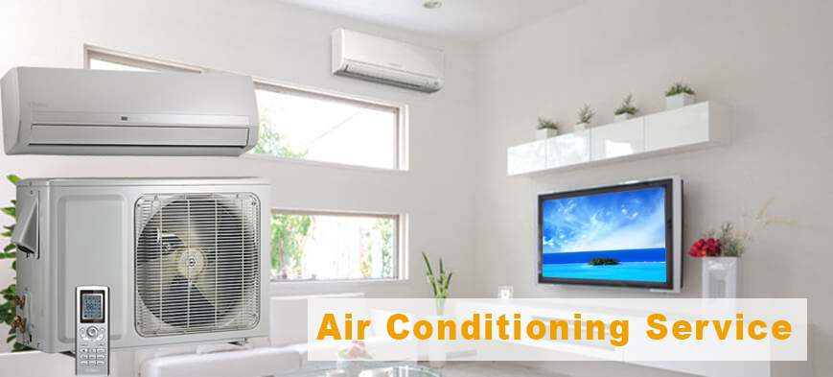
AIR CONDITIONING SERVICES IN WINNIPEG
Installation - Cleaning - Maintenance - Repair & replacement

- Duct Cleaning
Greater Efficiency - Prolonged life -Reduction of energy costs- Improved indoor air quality
Contact us for a quote

- Keeping families comfortable since 1996
Book online & save $60 off your complete package to service/clean your furnace, ducts & A/C
Book now

Use the same images and colors from the website
- Make sure all keywords are hyperlinked where required
- All images should be named based on that service keyword
- Alt tags and meta tags
- SEO friendly urls

Pages
Page heading and page url

Heating/Furnace - www.eastsideventilation.ca/residential/furnaces-heating-winnipeg
Home Furnace Installation Winnipeg- www.eastsideventilation.ca/residential-home-furnace-installation-winnipeg
Furnace Cleaning- www.eastsideventilation.ca/residential/home-furnace-cleaning-winnipeg
Furnace Service- www.eastsideventilation.ca/residential/home-furnace-service-winnipeg
Furnace Repair & Replacement - www.eastsideventilation.ca/residential-home-furnace-repair-company-winnipeg

Heat Recovery Ventilators –HRV – www.eastsideventilation.ca/Heat-Recovery-Ventilators-Winnipeg
Installation- www.eastsideventilation.ca/Heat-Recovery-Ventilators-HRV- Installation-Winnipeg
Repair & Replacement- www.eastsideventilation.ca/Heat-Recovery-Ventilators-HRV- repair-Winnipeg

Cooling/Air Conditioning
Installation - www.eastsideventilation.ca/new-AC- installation-Winnipeg
AC Cleaning- www.eastsideventilation.ca/air-conditioner-cleaning-company-Winnipeg
AC Service- www.eastsideventilation.ca/air-conditioner-service-Winnipeg
AC Repair & Replacement - www.eastsideventilation.ca/air-conditioner-repair-Winnipeg

Duct Cleaning Winnipeg- https://www.eastsideventilation.ca/residential/duct-cleaning-company-winnipeg

Air Quality & Dust

Manitoba Hydro Program

New Home HVAC Systems

Multi-Family HVAC Systems

Use the contents for the above pages from the existing website

Page contents
Home page

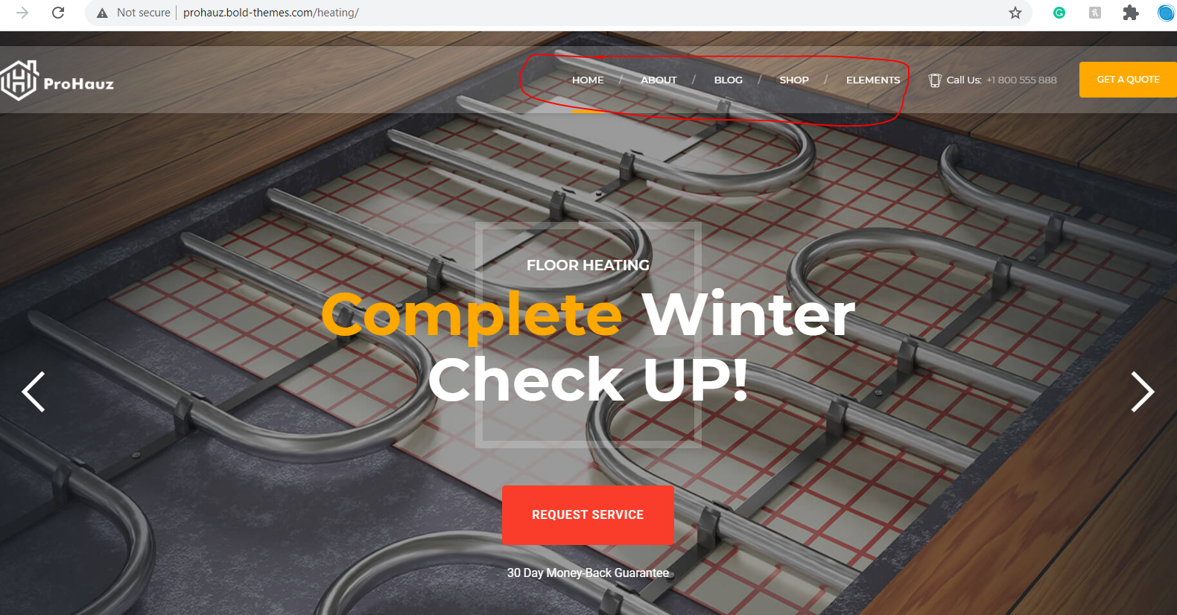
Replace the tabs to the below
Change the Get a Quote to click here for Commercial Services and that should redirect to a different link

Home to HVAC
- Page url – eastsideventilation.ca/hvac-company-winnipeg
- Replace the other tabs to
Heating & Furnaces
    - Installation – page urls listed above
    - Cleaning – page urls listed above
    - Service – page urls listed above
    - Repair & Replacement– page urls listed above
HRV
Installation
Repair and Replacement
AC & Cooling
Install
Clean
Service
Repair and Replacement
Duct Cleaning

Contact
List below and have hyperlinks to those appropriate pages
- Heating/Furnace
- Cooling/Air Conditioning
- Duct Cleaning
- Air Quality & Dust
- Manitoba Hydro Program
- New Home HVAC Systems
- Multi-Family HVAC Systems

Use all the present contents from the home in the new website layout including the images

Footer links

East Side Ventilation HVAC New Home HVAC Systems
Services Manitoba Hydro Program Multi Family HVAC Systems
Brands Duct Cleaning Tips
Address and Contact Info Furnace Company Promotions
Careers AC Experts Commercial Services

Careers page
Each role should open in a new page
At East Side Ventilation, we hire and nourish individuals with the right skill and talent. We hire employees in all sectors within our company from time to time.
Apply for the role which you have experience with and we will get back to you once the role is available

HVAC Technician – page url website/Winnipeg-HVAC-technician
Experienced Commercial Refrigeration/HVAC Technician
Please apply with your resume and cover letter:

First name Last name
Email Address
Phone number
Role applying for:
Resume Attachment
Cover Letter Attachment

Google captcha

Email should go to davem@esvent.ca and BCC simonwtss@gmail.com

HVAC Refrigeration Technician
Page url - website/Winnipeg-HVAC-Refrigeration-Technician

AC Mechanic
Page url website/Winnipeg-HVAC-Refrigeration-Technician

HVAC Sheet Metal Installers Winnipeg
Page url website/ HVAC-Sheet-Metal-Installers-Winnipeg

Air Duct Cleaning Technician Winnipeg
Page url website/ Air-Duct-Cleaning-Technician-Winnipeg

Office Administrator -HVAC Company
Page url website/ Office-Administrator-HVAC-Company-Winnipeg

Email Subscribers list
First Name Last Name
Email Address
I accept to the terms and conditions and would like to subscriber to East Side Ventilation Promotions and Newsletters

In the home page above the footer have the affiliations icons/logos moving

Brands page

At East Side Ventilation, we offer a variety of brands to serve your needs based on your requirements.



Manitoba Hydro Financing
Page name website/hvac-Manitoba-hydro-financing

You don’t have to break the bank just to be comfortable.

